**Social network API**

December & 2019

Contents

Team 3

Document Purpose and Audience 3

System Models 4

I. System Decomposition 4

II. Class diagrams 5

III. Sequence diagrams 13

Class - Sequence Usage Table 18

# 

# Team

|  |  |
| --- | --- |
| **ID** | **Name** |
| 20170160 | Abdallah mohamed naguib |
| 20170212 | Mohamed ahmed saad |
| 20170094 | Hussien tarek |

# Document Purpose and Audience

## This document is presenting component diagram , class UML and sequence diagram. It is for a back-end API (Application Programming Interface) for a Social Network, which is a dedicated website which enables users to communicate with each other by posting information, comments, messages, images, like Facebook, etc..

## It targets the developers team who will work on this project

## It targets also the project manager, who is responsible for the whole project.

# 

# System Models

## I. System Decomposition

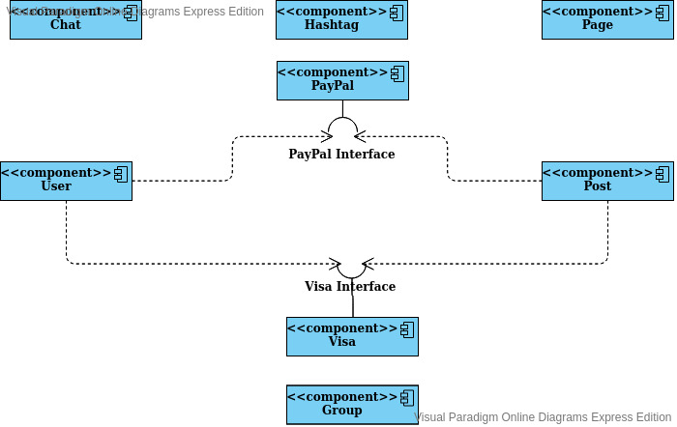

## II. Class diagrams

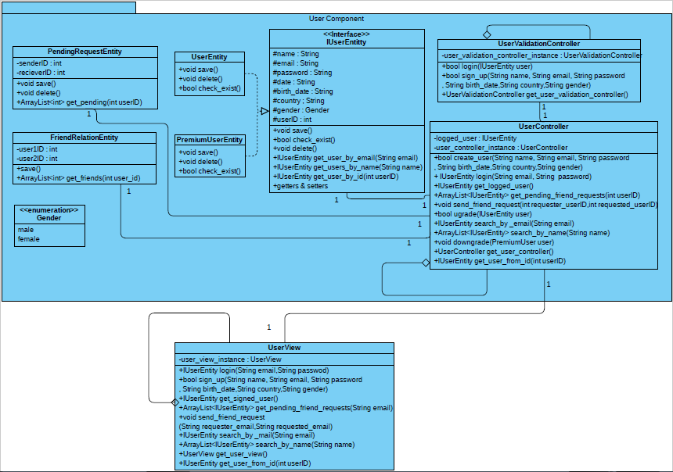

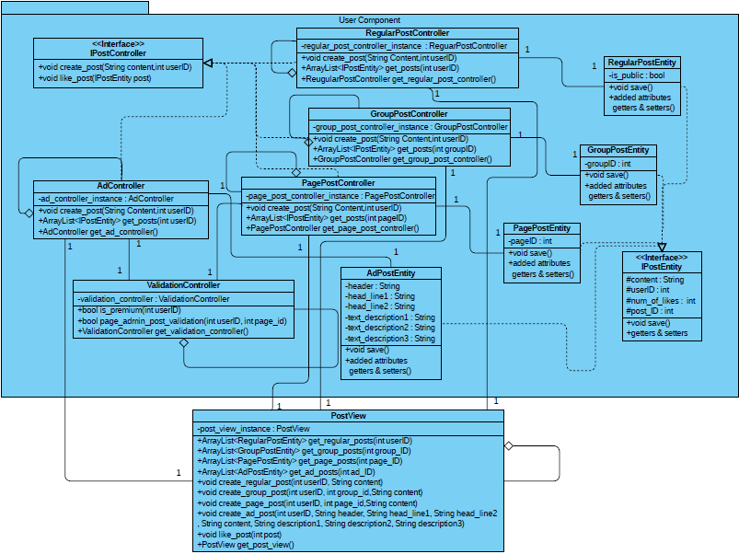

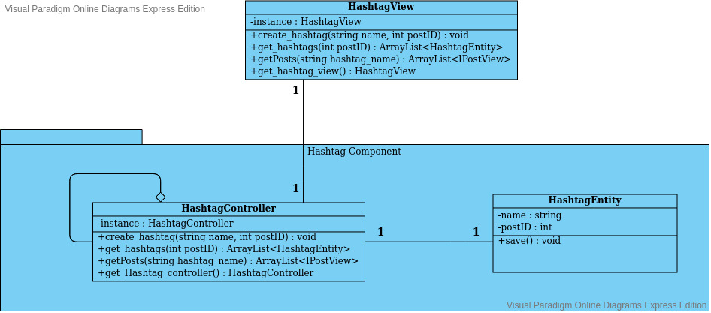

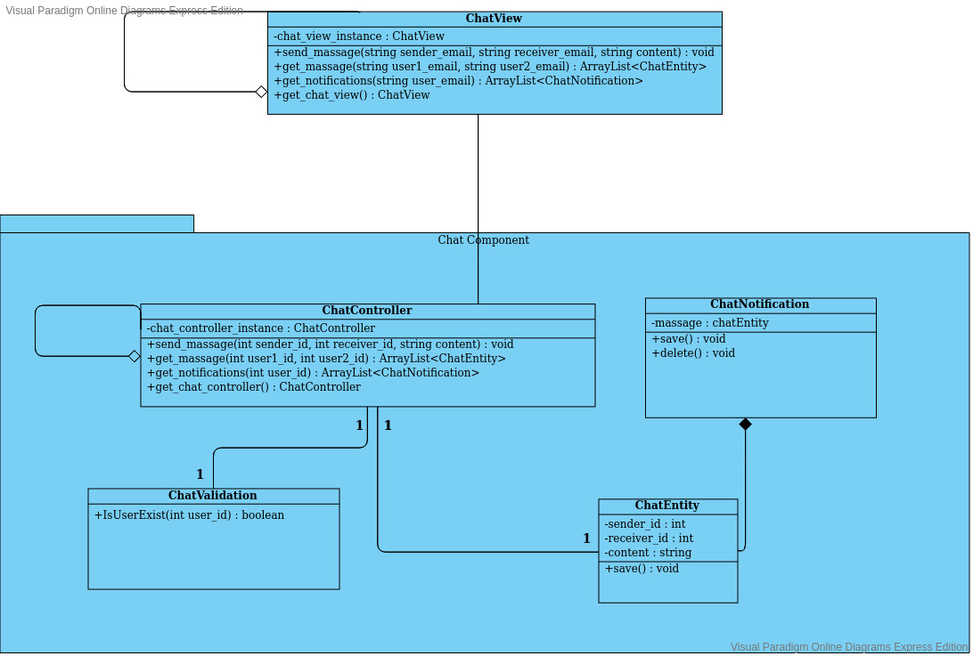

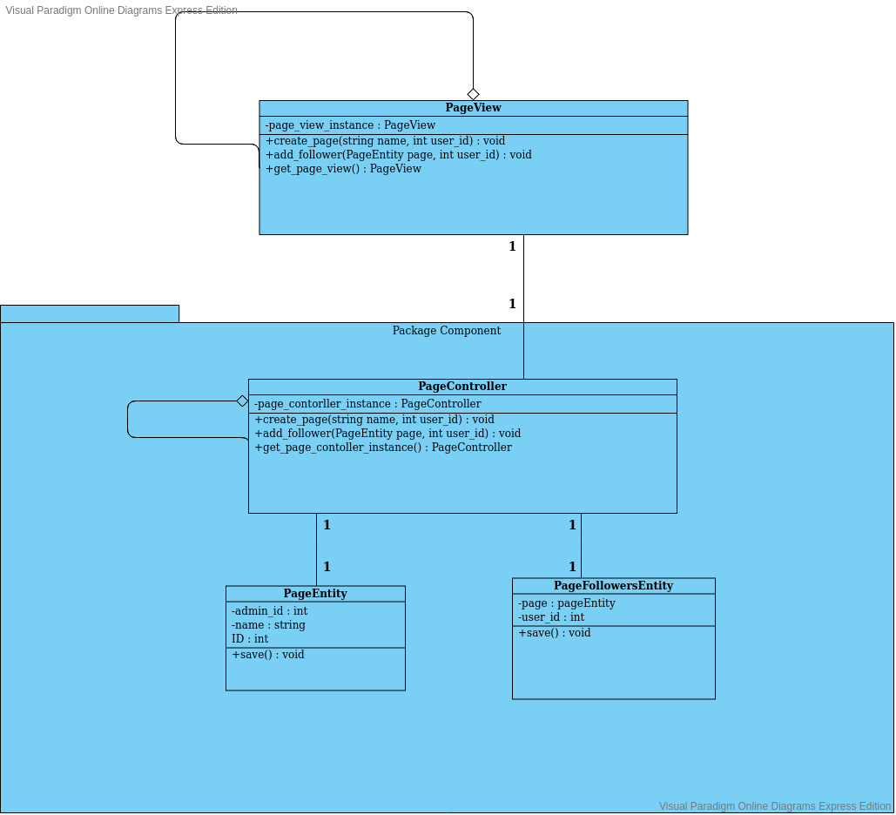

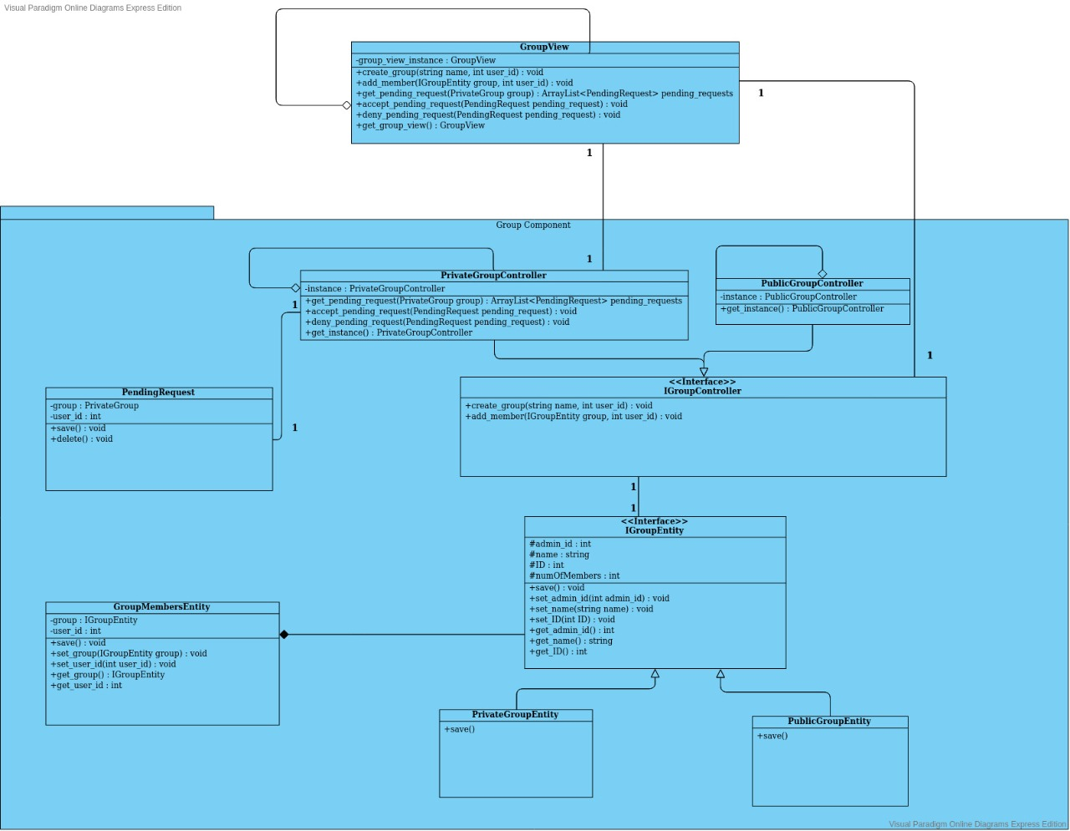

| **Class ID** | **Class Name** | **Subsystem ID** | **Description & Responsibility** |
| --- | --- | --- | --- |
|  | PageEntity | Page | Saves Page data & manipulate it |
|  | PageController | Page | Manages & do requested services by view & save it's effect through entities |
|  | PageView | Page | Interface for Services of Page component |
|  | PageFollowersEntity | Page | Save page Followers in the database |
|  | HashtagEntity | Hashtag | Saves Hashtag data & manipulate it |
|  | HashtagController | Hashtag | Manages & do requested services by view & save it's effect through entities |
|  | HashtagView | Hashtag | Interface for Services of Hashtag component |
|  | ChatEntity | Chat | Saves Chat data & manipulate it |
|  | ChatController | Chat | Manages & do requested services by view & save it's effect through entities |
|  | ChatView | Chat | Interface for Services of Chat component |
|  | ChatNotification | Chat | Save massage notification in the database whenever there is a massage, in order to view all of them by get_notifications() function in ChatController class |
|  | ChatValidation | Chat | Controls Validation operations on data entered through view |
|  | PrivateGroupEntity | Group | Saves Private Group data & manipulate it |
|  | PublicGroupEntity | Group | Saves Public Group data & manipulate it |
|  | IGroupEntity | Group | Interface for both public and private group Entities |
|  | PrivateGroupController | Group | Manages & do requested services by view & save it's effect through private group entities |
|  | PrublicGroupController | Group | Manages & do requested services by view & save it's effect through public group entities |
|  | IGroupController | Group | Interface for both public and private group Controllers |
|  | GroupView | Group | Interface for Services of Group component |
|  | GroupMembersEntity | Group | Save group members in the database |
|  | PendingRequest | Group | Save pending requests to join a private group so that admin of the group can confirm or refuse these requests |

| **Class ID** | **Class Name** | **Subsystem ID** | **Description & Responsibility** |
| --- | --- | --- | --- |
|  | UserView | User | Interface for Services of User component |
|  | UserController | User | Manages & do requested services by view & save it's effect through entities |
|  | UserValidationController | User | Controls Validation operations on data entered through view |
|  | UserEntity | User | Saves user data & manipulate it |
|  | PremiumUserEntity | User | Saves Premuinm user data & manipulate it |
|  | PendingRequestEntity | User | Saves friend requsts data & manipulate it so user can check it later |
|  | FriendRelationEntity | User | Maps friend relationships among users pairs data & manipulate it |
|  | PostView | Post | Interface for Services of Post component |
|  | RegularPostController | Post | Manages & do requested services for post by view & save it's effect through post entity |
|  | PagePostController | Post | Manages & do requested services for Page by view & save it's effect through Page entity |
|  | GroupPostController | Post | Manages & do requested services for Group by view & save it's effect through Group entity |
|  | AdPostController | Post | Manages & do requested services for Ad Post by view & save it's effect through Ad Post entity |
|  | ValidationController | Post | Controls Validation operations for users to do premium users pages admins extra features |
|  | RegularPostEntity | Post | Saves Regular Post data & manipulate it |
|  | PagePostEntity | Post | Saves Page Post data & manipulate it |
|  | GroupPostEntity | Post | Saves Group Post data & manipulate it |
|  | AdPostEntity | Post | Saves Ad Post data & manipulate it |

## III. Sequence diagrams

**1 – Add Ad**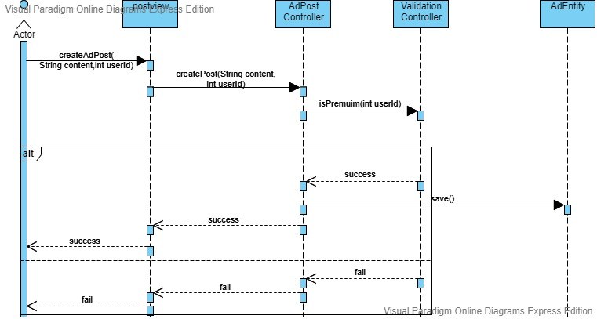

### 2- Add post

### 

### 3 – join group

### 

### 4 – send msg

### 

### 5 – sign in

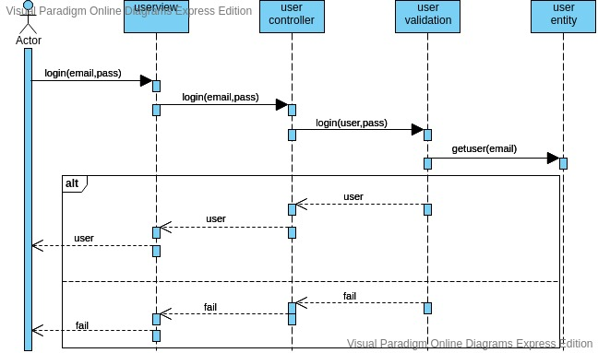

### 6 – sign up

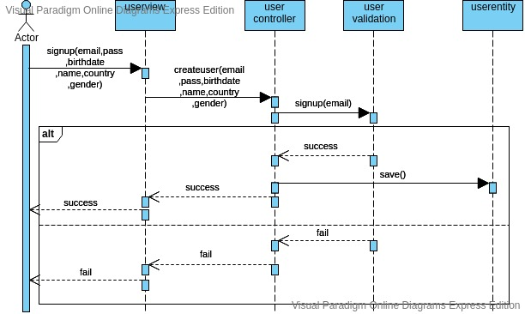

### Class - Sequence Usage Table

| **Sequence Diagram** | **Classes name** |
| --- | --- |
| 1 | Postview , Adcontroller , AdValidation , AdEntity |
| 2 | Postview , RegPostContoller , RegPostEntity |
| 3 | Groupview , PrivateGroupController , PendingRequest |
| 4 | Chatview , chatcontroller , chatvalidation , ChatNotification , UserEntity |
| 5 | UserView , UserController , UserValidation , UserEntity |
| 6 | UserView , UserController , UserValidation , UserEntity |